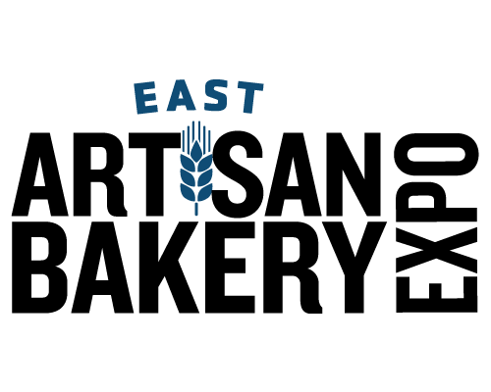 | Action Item Checklist
October 16-17, 2022 ● Atlantic City Convention Center ● Atlantic City, NJ

Use this checklist as your guideline for important deadline dates for the show. Be sure to meet the discount deadlines as these can save you money over on-site prices.

Due Date | Order Form | Return to
ASAP | Exhibitor Badge Registration | Submit Electronically  Questions? Call (770) 291-5492
ASAP | Hotel Reservation | onPeak  Questions? Call (855) 906 2787
ASAP | Floral Order Form | TLC National
ASAP | Exhibitor Liability Insurance Enrollment | Marsh/TotalEvent
August 7 to September 16 | Tiered Lead Retrieval Forms | Maritz Global Events
September 14 | Advance Shipments to the Freeman Warehouse Begins | Freeman
September 16 | Food & Beverage Sampling Form | Submit Electronically to Show Management
September 16 | Fire Safety Permit Application | Submit Electronically to Show Management
September 16 | Catered Food & Beverage | ACCC – Spectra Food Service
September 23 | Carpet & Flooring Order Form | Freeman
September 23 | Tables & Accessories Order Form | Freeman
September 23 | Frozen & Refrigerated Food Storage Order Form | Freeman
September 23 | Freeman Exhibit Packages | Freeman
September 23 | Coming Soon! Material Handling Order Form | Freeman
September 23 | Freight Services Information | Freeman
September 23 | Labor Order Form | Freeman
September 23 | Graphics & Signs Order Form | Freeman
September 28 | Telephone & Internet Order Form | SmartCity
September 30 | Certificate of Insurance  All Exhibiting Companies  All EAC’s | Submit Electronically to Show Management
September 30 | Purchase Exhibitor Insurance (if needed) | Purchase Electronically  with Marsh/Total Event Insurance
October 1 | Electrical, Plumbing & Lighting Truss/Motorized Hoist Form | ACCC Utilities
October 7 | Last Day Advance Shipment to Freeman Warehouse | Freeman
October 14 | Direct Shipments to ACCC Begin (Show Site Shipping Label) | Freeman

